ICT ACADEMY OF KERALA
Summer Internship Report

Full Stack Application Development

with ReactJS
Project: Study & Task Hub

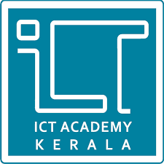

Lakshmi Nandana O R
Sahrdaya College of Engineering and Technology, Kodakara
26.10.2026

EXECUTIVE SUMMARY
This report presents the design, development and deployment of Study & Task Hub, a full-stack web application built on the MERN stack (MongoDB, Express.js, React and Node.js) as the project work of the Summer Internship in Full Stack Application Development with ReactJS at ICT Academy of Kerala. The platform is a productivity and study-management tool that allows students to organise tasks and assignments, plan a weekly class timetable, track focused study time with a Pomodoro timer and manage their daily workflow from a single, responsive dashboard.
The principal objective of the project was to apply the complete web development lifecycle to a real, student-focused problem: gathering requirements, modelling data, building a secure REST API, creating an interactive React interface, and releasing the product on cloud infrastructure. Key activities included designing the MongoDB data model with Mongoose, implementing the back end using the Model-View-Controller (MVC) pattern, building a secure authentication workflow with password hashing and token-based verification, developing a dark-themed interface with React, Vite and Tailwind CSS, and integrating a Pomodoro focus timer, a weekly timetable planner and a productivity overview.
The outcome is a fully working application that is publicly accessible. The front end is deployed on Vercel, the back end on Render, the database is hosted on MongoDB Atlas, and the source code is version-controlled on GitHub with automatic builds triggered from the repository. The project strengthened practical skills in full-stack development, API design, authentication, UI engineering and DevOps.

INTRODUCTION

1.1 Background
Students must balance lectures, assignments, laboratory records, examinations and self-study, often with competing deadlines. These responsibilities are usually tracked in a mixture of notebooks, messaging apps and memory, which makes it easy to lose sight of priorities and to underestimate the time a task requires. Effective time and task management is widely recognised as an important contributor to academic performance and to reducing stress.

1.2 Problem Statement
Students lack a single, simple and focused place to record academic tasks, classify them by priority, status and deadline, and measure the time they actually spend studying. Without such a system, deadlines are missed, work is not prioritised effectively, and there is no objective view of study habits.

1.3 Existing Solutions and Their Limitations
General-purpose to-do applications and project-management tools are available, but many are designed for professional teams and carry complexity, pricing tiers or features that students do not need. Stand-alone timer applications, on the other hand, are rarely connected to the tasks a student is working on. This separation of task tracking and time tracking leaves a gap for a lightweight, student-centred tool that combines both.

1.4 Proposed Solution
Study & Task Hub addresses this gap by combining task management, study-session tracking and productivity timers in one web application. Each student registers an account and receives a private workspace in which tasks can be created with a subject, due date and priority, marked complete, searched, sorted and removed, a weekly class timetable can be maintained, and a built-in Pomodoro timer helps monitor focused study intervals. The interface is responsive so that it can be used on a laptop between classes or on a phone at home.

1.5 Rationale for the MERN Stack
The MERN stack was selected because it allows the entire application, from the browser to the database, to be written in JavaScript and to exchange data as JSON. React provides a component-based approach for building interactive interfaces; Node.js and Express.js offer a lightweight, non-blocking runtime for REST APIs; and MongoDB's document model maps naturally to JavaScript objects, which simplifies development and iteration. The stack is also widely adopted in industry, which makes the skills gained directly relevant to professional practice.

OBJECTIVES
The project was undertaken with the following objectives, which also reflect the skills intended to be developed during the internship:
- Design and develop a full-stack MERN web application that meets the task-management and study-tracking needs of students.
- Implement secure user registration, login and session management, using password hashing and token-based verification, so that each user's data is isolated and protected.
- Build a RESTful API with Node.js and Express.js, structured according to the MVC design pattern for a clear separation of concerns.
- Model, validate and persist application data in MongoDB Atlas using the Mongoose ODM, with complete CRUD functionality for tasks.
- Create a responsive, modern, dark-themed user interface using React, Vite and Tailwind CSS, with client-side routing between the Tasks & Notes, Weekly Timetable and Pomodoro Focus views.
- Integrate a Pomodoro focus timer, a productivity overview and a weekly timetable planner that help students manage study time and monitor completion of their work.
- Deploy the application to cloud platforms and apply version control and continuous deployment practices using Git, GitHub, Vercel and Render.

Skills Targeted
- Full-stack JavaScript development and component-based UI design with React.
- REST API design, MVC architecture and NoSQL data modelling.
- Authentication, authorisation and secure handling of user credentials.
- Responsive design with utility-first CSS.
- Cloud deployment, environment configuration and Git-based workflows.

SCOPE AND DELIVERABLES

3.1 Scope of the Project
The scope covered the end-to-end development of a web application, from requirement analysis to public deployment. The work was carried out across the following areas:
- User authentication: secure sign-up, login and session management with user-specific data isolation.
- Task management: creating, completing, searching, sorting and deleting study tasks and assignments, each with a subject or category, due date and priority.
- Productivity modules: a Pomodoro focus timer, a productivity overview (total tasks, finished tasks and focus time today) and a weekly timetable for planning classes.
- Responsive client interface: a layout that renders consistently across desktop, tablet and mobile screen sizes.
- Personalisation: three selectable colour themes (Midnight Blue, Emerald Dark and Sunset Violet).
- Back-end services: a REST API with MVC structure, validation and database communication through Mongoose.
- Deployment and version control: hosting on Vercel and Render, with the source code maintained on GitHub.
The project is delivered as a responsive web application accessed through a browser; native mobile applications were outside its scope.

3.2 Deliverables
Deliverable | Description | Location
Front-end application | React + Vite single-page application styled with Tailwind CSS | https://study-task-hub-flame.vercel.app
Back-end API | Node.js and Express.js REST API following the MVC pattern | https://study-task-hub.onrender.com
Database | MongoDB Atlas cluster with Mongoose schemas and validation | MongoDB Atlas (cloud-hosted)
Source code | Version-controlled repository with full project history | https://github.com/lakshmi225062-beep/study-task-hub
Project report | This document, describing the design, implementation and results | Submitted with the repository

METHODOLOGY

4.1 Development Approach
The project followed an iterative and incremental approach. Requirements were first translated into a list of core features, after which the system was built in small vertical slices: the data model, the API endpoints and the user interface for one feature were completed and tested together before moving to the next. This kept the application in a working state throughout development and made it easy to refine features based on testing.

4.2 System Architecture
Study & Task Hub uses a three-tier client-server architecture. The React client runs in the user's browser and communicates with the Express.js server through HTTPS requests that exchange JSON. The server applies business logic and authentication checks and uses Mongoose to read from and write to MongoDB Atlas. Figure 1 illustrates this structure and the platform on which each tier is hosted.
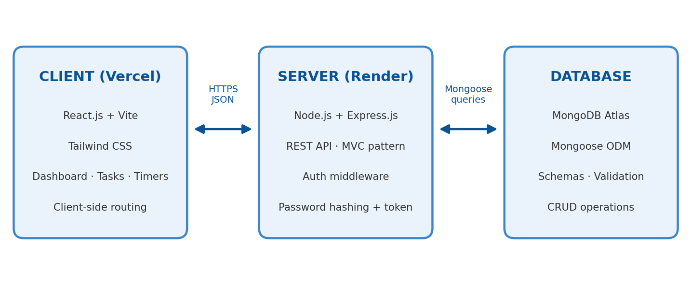
Figure 1: System architecture of Study & Task Hub

4.3 Technologies and Tools
Layer | Technology | Role in the project
Front end | React.js, Vite | Component-based UI with client-side routing; Vite provides fast bundling and hot module replacement
Styling | Tailwind CSS | Utility-first styling for a responsive, modern, dark-themed interface
Back end | Node.js, Express.js | RESTful API server organised using the MVC design pattern
Database | MongoDB Atlas, Mongoose | Cloud NoSQL database with schema modelling, validation and CRUD operations
Security | Password hashing, token/session verification | Protects user credentials and restricts API routes to authorised users
Version control | Git, GitHub | Source management and trigger for automatic deployments
Hosting | Vercel, Render | Front-end hosting and back-end API hosting respectively

4.4 MVC Design Pattern
The back end is structured according to the Model-View-Controller pattern. Models define the Mongoose schemas and validation rules for the data stored in MongoDB. Controllers contain the logic that handles each request, such as creating a task or authenticating a user. Routes map REST endpoints to the appropriate controllers, and the JSON responses returned to the React client serve as the view layer of the API. Separating these responsibilities keeps the code readable, testable and easier to extend.

4.5 Authentication and Security Approach
User passwords are never stored in plain text; they are hashed before being saved to the database. After a successful login the server issues a token that the client presents with subsequent requests, and protected API routes verify this token before granting access. Because every task is associated with the authenticated user, each student can only read and modify their own data, which provides the required data isolation.

4.6 Deployment and DevOps Workflow
The source code is maintained in a public GitHub repository. The Vercel project is connected to this repository so that every push triggers an automatic build and deployment of the front end. The back end is deployed separately on Render and exposes the REST API that communicates with MongoDB Atlas. This arrangement keeps the client and server independently deployable and allows updates to either to be released without affecting the other.

PROJECT ACTIVITIES
The work was carried out in the following phases, each building on the previous one.

5.1 Requirement Analysis and Planning
The needs of a typical student were analysed and converted into functional requirements: secure accounts, task CRUD operations, categorisation by priority, status and deadline, study timers and a responsive interface. The MERN stack and the hosting platforms were selected, and the application was divided into front-end, back-end and database modules.

5.2 Environment Setup and Version Control
The React project was scaffolded with Vite and configured with Tailwind CSS, while the Node.js and Express.js server was initialised as a separate project with its dependencies. A Git repository was created and hosted on GitHub, and work was committed regularly so that the history documents the progress of the project.

5.3 Database Design
A MongoDB Atlas cluster was provisioned and connected to the server using Mongoose. Data was modelled around two central entities, summarised below, with validation rules to ensure that only well-formed data is stored.
Entity | Purpose and key characteristics
User | Represents a registered student. Stores account details and a hashed password, and acts as the owner of the user's tasks.
Task | Represents a study task or assignment. Records its title, subject or category, due date, priority and completion status, and is linked to the user who owns it so that data remains private.
Timetable entry | Represents a class in the weekly timetable. Records the day, time, subject name and an optional room or meeting link.

5.4 Back-End Development
The REST API was developed with Express.js using the MVC pattern. Registration and login endpoints were implemented with password hashing and token generation, and middleware was added to protect private routes. Task endpoints provide the create, read, update and delete operations, always scoped to the authenticated user. Errors and invalid input are handled consistently and reported to the client in a clear format.

5.5 Front-End Development
The interface was built from reusable React components. Client-side routing provides seamless navigation between the Tasks & Notes, Weekly Timetable and Pomodoro Focus views without full page reloads. Three colour themes (Midnight Blue, Emerald Dark and Sunset Violet) can be selected from the header. Tailwind CSS was used to create a consistent dark theme and a responsive layout that adapts to different screen sizes.

5.6 Pomodoro Timer, Productivity Overview and Weekly Timetable
A Pomodoro focus timer with a 25-minute work session and start, pause and reset controls lets students study in timed intervals; completed sessions are logged automatically to their study statistics. A productivity overview on the task page shows the total number of tasks, the number finished and the focus time for the day, with a progress bar. A weekly timetable lets students add classes by day, time, subject and optional room or link, and view them in a seven-day layout.

5.7 Integration, Testing and Deployment
The React client was connected to the Express API and the complete flows (registration, login, task management, timetable and timers) were tested end to end. The front end was then deployed to Vercel with automatic builds from GitHub, and the back end was deployed to Render, with environment variables configured for the database connection and token settings.

5.8 Challenges and Solutions
Challenge | Approach adopted
Connecting a separately hosted client and server | Configured cross-origin resource sharing (CORS) on the API and used environment variables for the API address in each environment.
Protecting user data | Introduced authentication middleware and tied every task to its owner so that routes only return the authenticated user's records.
Keeping the interface consistent across screen sizes | Used Tailwind CSS responsive utilities and a reusable component structure.
Managing secrets and settings across environments | Stored the database connection string and token settings as environment variables on the hosting platforms rather than in the source code.

RESULTS & FINDINGS

6.1 Functional Outcomes
All planned features were implemented and verified in the deployed application.
Feature | Outcome | Status
User authentication | Students can register, log in and log out; passwords are hashed and routes are protected by token verification. | Completed
Task management | Tasks and assignments can be added with a title, subject or category, due date and priority, marked complete and deleted. | Completed
Search and sorting | Tasks can be searched by title or subject and sorted by newest, oldest or priority. | Completed
Productivity overview | Shows total tasks, finished tasks and focus time today, with a progress bar. | Completed
Pomodoro focus timer | A 25-minute timer with start, pause and reset controls; completed sessions are logged to study statistics. | Completed
Weekly timetable | Classes can be added by day, time, subject and optional room or link and are shown in a seven-day view. | Completed
Themes and responsive interface | Three colour themes are available and the layout adapts to different screen sizes. | Completed
Cloud deployment | Front end on Vercel, back end on Render and database on MongoDB Atlas are all live. | Completed

6.2 Deployment Results
Component | Platform | Live URL
Front end | Vercel | https://study-task-hub-flame.vercel.app
Back end | Render | https://study-task-hub.onrender.com
Source code | GitHub | https://github.com/lakshmi225062-beep/study-task-hub

6.3 Key Findings
- The MVC structure kept the back end organised and made it easy to add or modify features without affecting unrelated code.
- Using JavaScript throughout the stack reduced context switching and allowed data to flow as JSON from the database to the interface.
- Tailwind CSS made it quick to build a consistent, responsive dark-themed interface.
- Connecting GitHub to Vercel automated builds, so changes could be released with a single push.
- Associating each task with its owner and verifying tokens on protected routes gives every student a private workspace.

6.4 Application Screenshots
The following figures show the main screens of the deployed application.
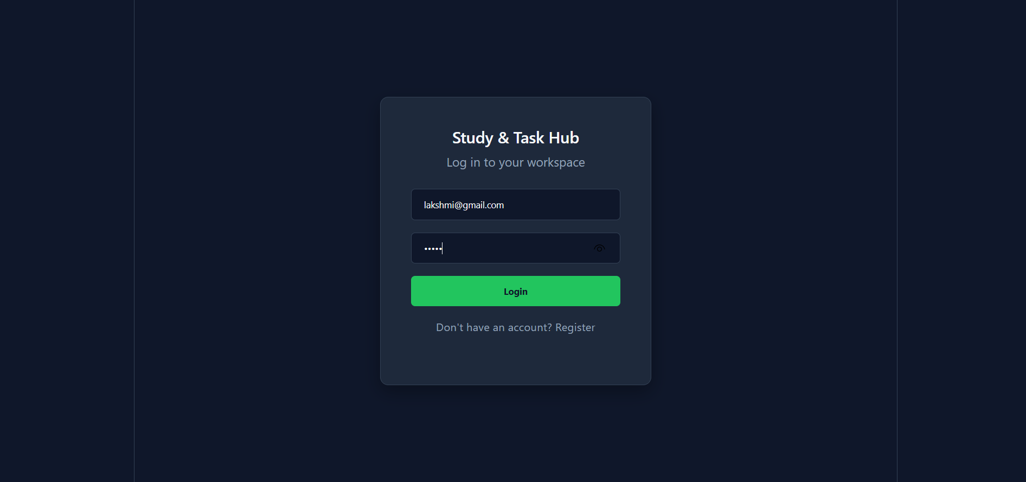
Figure 2: Login screen of Study & Task Hub
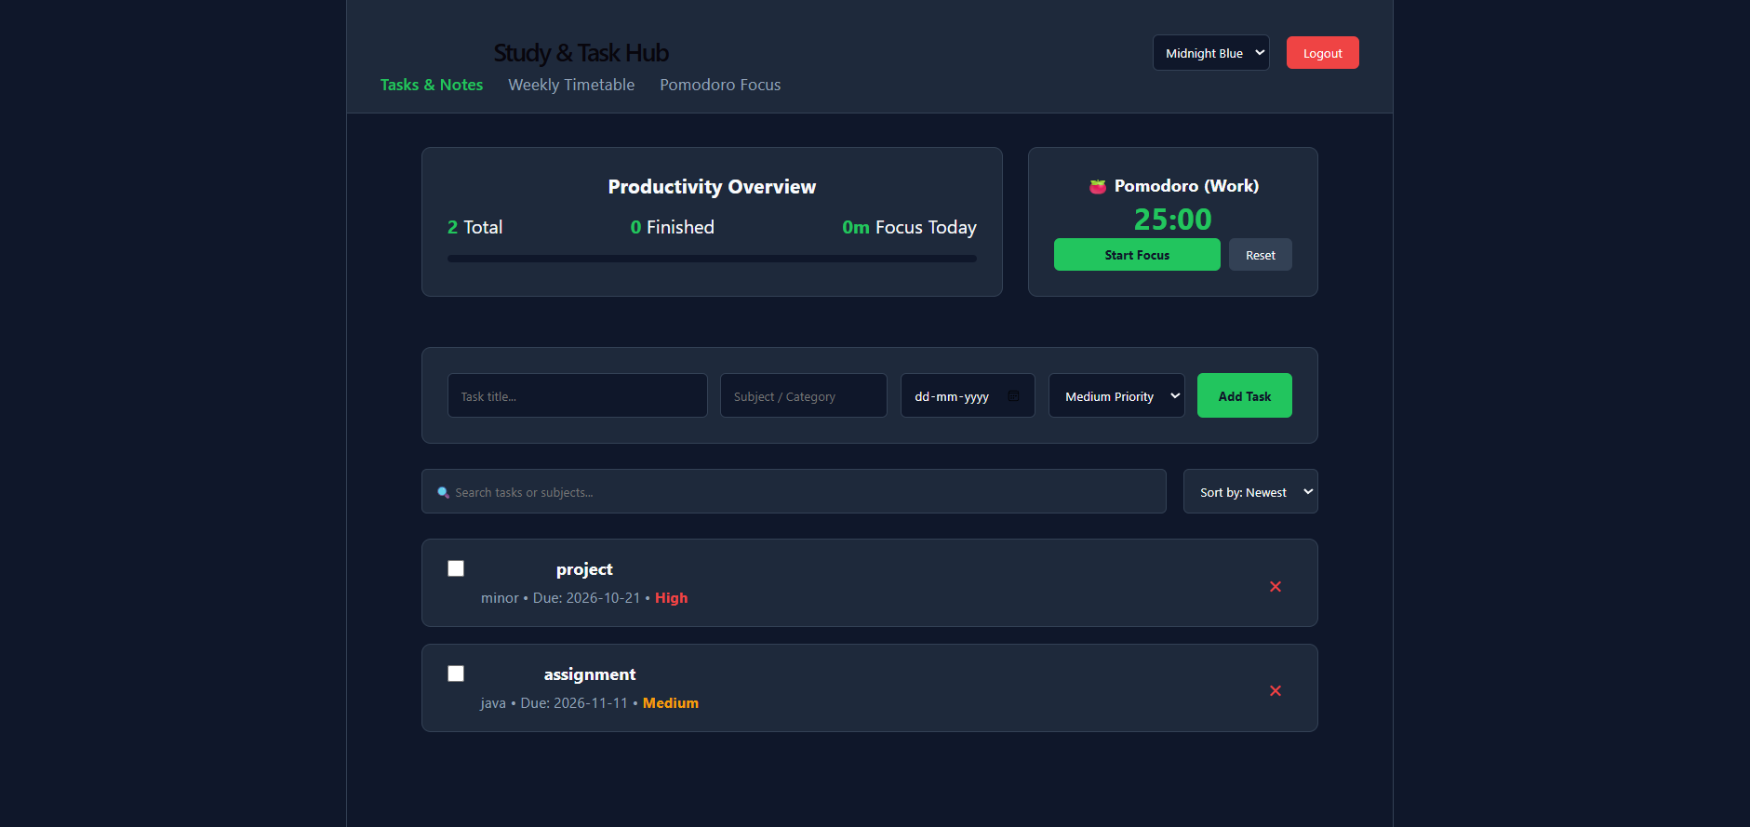
Figure 3: Tasks & Notes view with productivity overview, Pomodoro widget and task entry form
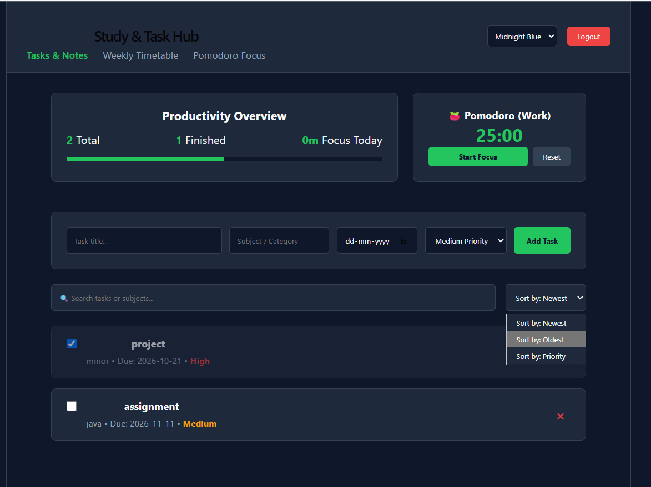
Figure 4: Completing tasks and sorting by newest, oldest or priority
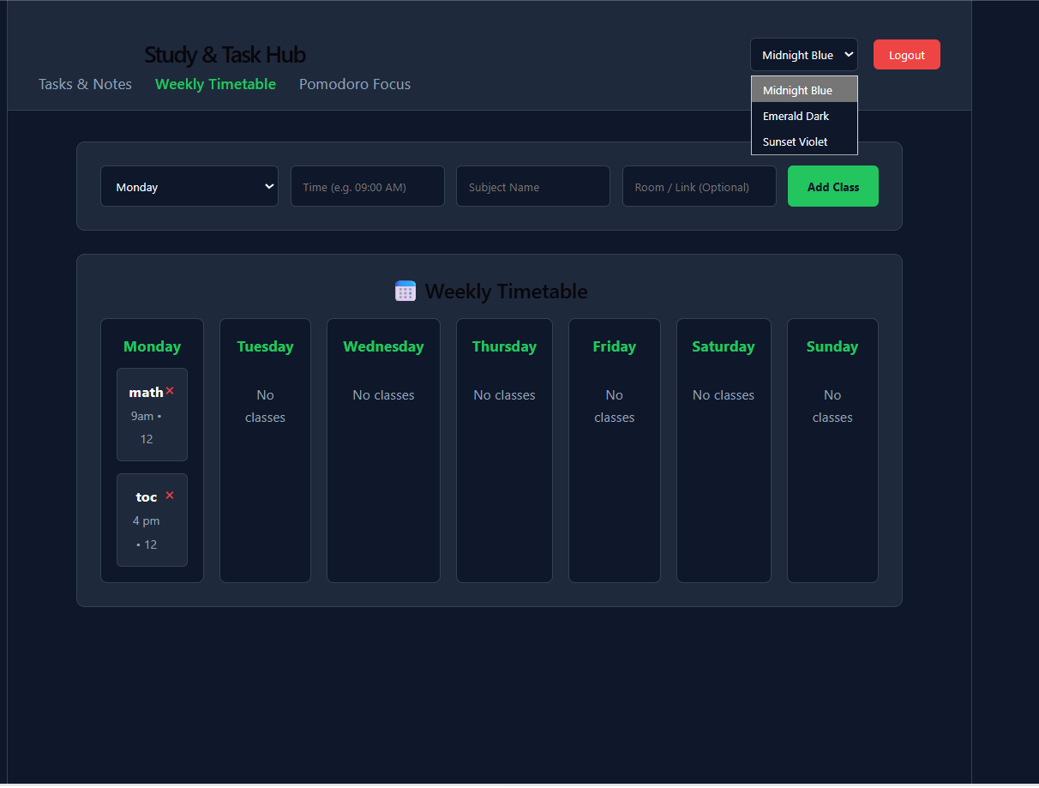
Figure 5: Weekly Timetable view with theme options
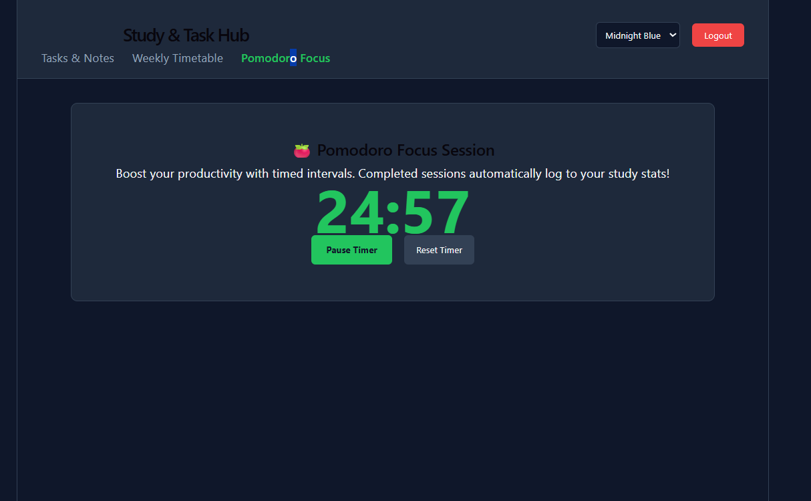
Figure 6: Pomodoro Focus session timer

6.5 Limitations and Future Enhancements
The current version focuses on the core task-management and timer workflow. The following enhancements could extend its usefulness:
- Detailed analytics and charts summarising study time and task completion over weeks and semesters.
- Email or push notifications for upcoming deadlines.
- Calendar integration and recurring tasks.
- Collaborative workspaces for group assignments and shared study sessions.
- Installable progressive web app (PWA) support with offline access.
- Automated unit and integration tests within a continuous integration pipeline.

CONCLUSION
The Study & Task Hub project successfully met its objectives. A complete MERN-stack application was designed, built and deployed, providing students with secure accounts, a task-management dashboard with subject, due-date and priority tracking, a weekly timetable and a Pomodoro focus timer for tracking study sessions. The application is publicly available, with its front end on Vercel, back end on Render and data stored in MongoDB Atlas.
Beyond the finished product, the internship provided hands-on experience across the whole development lifecycle: structuring a REST API with the MVC pattern, modelling data with Mongoose, implementing authentication, building a responsive interface with React and Tailwind CSS, and releasing software through Git-based continuous deployment. These skills form a strong foundation for future work, and the planned enhancements offer a clear path for the application to grow into a more complete academic companion.

APPENDIX

Appendix A: Project Resources
Resource | Link
Live application (front end) | https://study-task-hub-flame.vercel.app
REST API (back end) | https://study-task-hub.onrender.com
GitHub repository | https://github.com/lakshmi225062-beep/study-task-hub

Appendix B: Functional Requirements Summary
- User registration, login and session management with user-specific data isolation.
- Create, read, update and delete operations for study tasks and assignments.
- Tasks with subject or category, due date, priority and completion status, with search and sorting.
- Pomodoro focus timer, productivity overview and weekly timetable planner.
- Responsive layout across different screen sizes.

Appendix C: References
- React Documentation: https://react.dev
- Vite Documentation: https://vitejs.dev
- Tailwind CSS Documentation: https://tailwindcss.com/docs
- Node.js Documentation: https://nodejs.org/docs
- Express.js Documentation: https://expressjs.com
- MongoDB Atlas Documentation: https://www.mongodb.com/docs/atlas
- Mongoose Documentation: https://mongoosejs.com/docs
- Vercel Documentation: https://vercel.com/docs
- Render Documentation: https://render.com/docs

